CITIZENSHIP & IMMIGRATION/
TAXATION LAW

When Your Client Comes to Canada
CBSA officials, a US and Canadian Tax Accountant, a Relocation Expert and an Ontario Bar member will discuss the most important legal and logistics issues you must be aware when advising your client who is coming to Canada on a temporary or permanent basis. The following topics will be discussed:

- Top customs issues and how to avoid the pitfalls when moving goods to Canada,
- Settlers effects: what and when to bring goods to Canada…and what not to bring,
- Tax planning opportunities for newcomers: immigrant trusts and asset dispositions,
- Tax and customs issues and tips for temporary entry,
- Moving goods to Canada: logistics and security concerns in a changing world,
- Risk management in international relocations.

SPEAKERS: Jim Yaeger, Partner, International Executive Services, KPMG LLP
Bryan Sherman, Manager, Client Services Unit CBSA (Customs)
Yvette Campagne, Officer, Client Services Unit CBSA (Customs)
Robert Stone, The MI Group, Global Relocation Management

MODERATOR: Sergio R. Karas, Certified Specialist in Citizenship and Immigration Law and
Vice- Chair OBA Citizenship & Immigration Section

DATE: Wednesday, April 19, 2006

TIME: 12:00 p.m. – Registration & Buffet Lunch
12:30 p.m. – Program
LOCATION: OBA Conference Centre, 200-20 Toronto Street, Toronto
PRICE: $37.00 + $2.59 GST = $39.59 (OBA Member)
$60.00 + $4.20 GST = $64.20 (Non-Member)
$32.00 + $2.24 GST = $34.24 (OBA Law School/Articling Student Members)

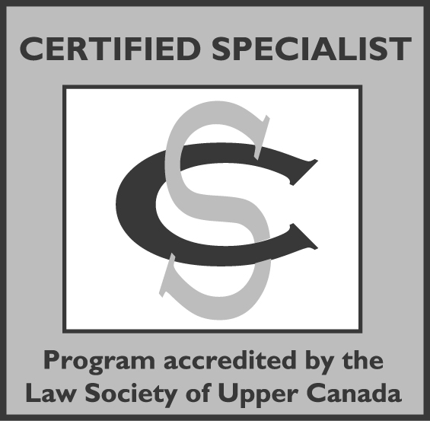
This Program has been accredited by the Citizenship & Immigration Law Specialty Committee of the Law Society of Upper Canada for 1.5 hours towards the professional development requirement for certification.
Phone-in Option available ($30 + GST). For information and reduced group rates for multiple registrations, please call (416) 869–1047 or 1(800) 668-8900 Ext. 307. GROUP RATE FOR PHONE- IN ONLY

REGISTRATION FORM & TAPE/CD ORDER FORM

PERSONAL INFORMATION CONSENT
The OBA’s programs may be supported by preferred suppliers, sponsors and exhibitors. Subject to the following paragraph, I understand that the provision of contact information on this registration form constitutes my consent to such information being disclosed to the preferred suppliers, sponsors, exhibitors, speakers or attendees of this program. For further information about the CBA’s and OBA’s treatment of personal information, see Members Privacy Policy at www.cba.org or www.oba.org
By checking this box □ I do not wish my contact information disclosed to the preferred suppliers, sponsors, exhibitors, speakers or attendees of this program.
To be completed and returned by Monday, April 17, 2006
Return together with cheque made payable to: Ontario Bar Association 300-20 Toronto Street, Toronto, ON M5C 2B8 or FAX your reservations to (416) 642-0424. ALL ORDERS MUST be prepaid.

CBA # Name:

Firm: _____________

Address:

City: Postal Code: Tel: _____

Fax: Email: ____________

My cheque is enclosed for $ Or please charge my: □ MasterCard □VISA

Card # Exp. Date:

Signature:
 □ I would prefer a vegetarian meal.
Program fee is refundable (less $10 + GST: administrative charge) only if notice in writing is received two business days prior to the program.
Walk-in registrations will only be accepted if accompanied by credit card or cheque. OBA cannot guarantee seating or meals for persons registering after the deadline.

Citizenship & Immigration – When Your Client Comes to Canada

□ Please register me for the live program
Date: Wednesday, April 19, 2006
Place: OBA Conference Centre, 200-20 Toronto Street, Toronto
Price:
$37.00 + $2.59 GST = $39.59 (OBA Member)
$60.00 + $4.20 GST = $64.20 (Non-Member)
$32.00 + $2.24 GST = $34.24 (OBA Law School/Articling Student Members)
I am unable to attend the program. Please send me:
□ CD-Audio (same price as cassette)
□ Audio Cassette
Members: $20.00 + $1.40 GST +$1.60 PST = $23.00
Non-members: $30.00 + $2.10 GST + $2.40 PST = $34.50
GST #R100760495

